Test Objective
This test script verifies the generation of RESTEasy procedures and WAR files in the Designer, and their execution in the server. The Create a REST WAR Action Guide will be used for this script.
Look for error messages which are difficult to understand, and other potential usability issues.

Test Setup
- Teiid Server and Teiid Designer must be installed and of compatible versions
- Applicable JDBC drivers are installed in the server and are available to the Designer (for importing)
- If your Designer isn't already connected to a Teiid Server, please use the Teiid Server Action Guide to establish a connection.

Testing Like a User
Here are some examples of user behavior which should be handled gracefully by our software. Verify we do.
- Resize dialogs taller, shorter, wider, narrower
- Enter bad data (white space, special characters, numbers at the beginning of a string, negative numbers)
- Use file names with, and without, file extensions. Use unexpected file extensions, like “.pdf” for a text file.
- Undo and Redo both of which are known to present problems (and may be disabled where it's truly non-functional)
- Refactoring should work in all places except VDBs, which have a difficult time with files that moved or changed name (it's a known limitation)
- Use the Back and Next buttons in the wizards
- Don't follow the “correct” sequence (modeling before creating a VDB). What happens if you do things differently?
- As you proceed ask yourself, “Do I understand what is being asked for?” We often take for granted the user speaks in our terms.

The Create a REST WAR Action Guide
When selected, this Action Guide will resemble the following:

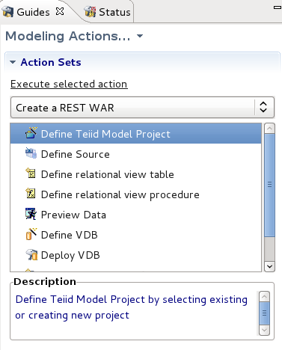

Define Teiid Model Project
- Click the New... button
- Enter the name of the project (for example, TestRest)
- Click Finish, or Next > to add folders (not necessary, but a good option to do)

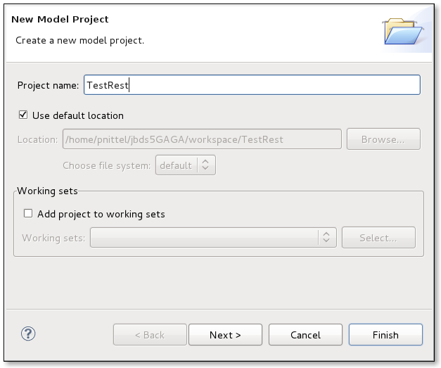

Define Source
- Double-click the Define Source action
- In the Define Data Source Models dialog, select the various options and launch the respective wizards. Cancel out of the wizard and proceed to the next. When you've been through at least a few, finally select the JDBC option and click the Launch button

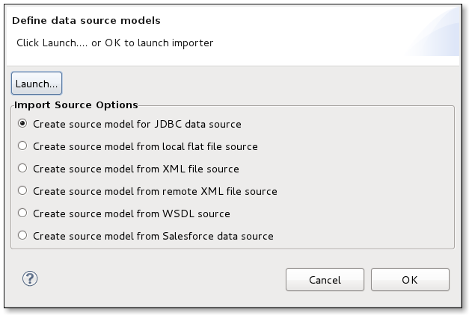

- Create a Connection Profile to import metadata from either of these two Books databases (you only need one for this test)
  - Import Books from Oracle
    - URL: jdbc:oracle:thin:@englxdbs11.mw.lab.eng.bos.redhat.com:1521:orcl
    - User: books
    - Password: mm
  - Import Books from SQL Server
    - URL: jdbc:sqlserver://slntdb02.mw.lab.eng.bos.redhat.com:1433;databasename=books
    - User: books
    - Password: mm
- Continue through the import process, naming the model BooksSource. Ensure the 'Use Fully Qualified Names' option on the last panel of the import wizard is checked (enabled).

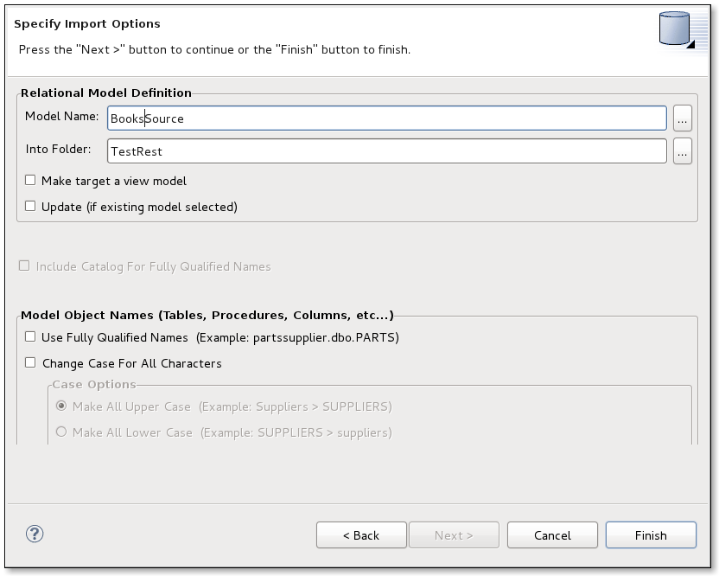

Define Relational View Table
- Double-click the Define relational view table action
- Create a new View model name (BooksInfo)
- Create a new Table name (bookInfoXXX)
- Use the properties tab to enter a description by pasting, and typing text. Enter a large amount, and edit it. Use special characters.
- Select the SQL tab
- Choose the various templates
- Choose the SELECT with Join Criteria option
- Go back to the properties tab and change the table name to “booksInfo”
The dialog will resemble this:

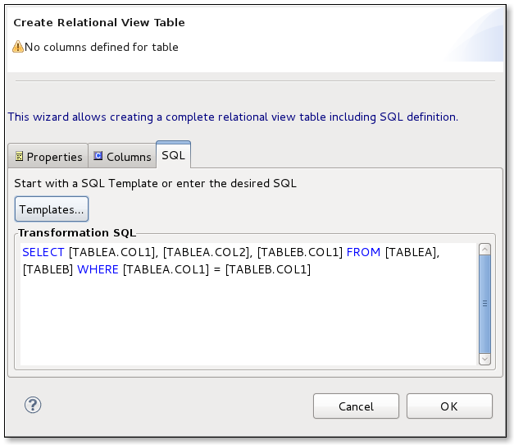
- Change the SELECT statement to
SELECT * FROM Books, Publishers WHERE CAST(publisher AS STRING) = CAST(publisher_id AS STRING)
- Click OK

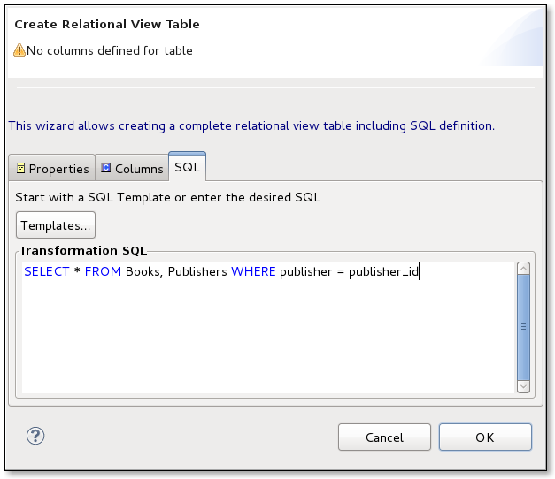

- Click OK to dismiss the transformation editing
- Click OK to finish defining the table

Defining the Relational View Procedure – (Action is missing!!)
- Start the action by double-clicking the Define relational view procedure action
- Define the name (and verify what is valid)
  - Start with a number
  - Name with white space
  - Name with special characters
  - Finally, “getBook”
  - When you define the name (getBook), you may also define parameters
  - Switch to the Parameters tab
  - Add one parameter named isbnInXXX with some type and length
  - Switch to the SQL tab
  - Enter some invalid SQL, like a simple SELECT statement without the procedure wrapper text
  - Switch back to the Parameters tab
  - Correct the parameter name to isbnIn and the type to string with a length of 25

This is the correct SQL.

CREATE VIRTUAL PROCEDURE
BEGIN
SELECT XMLELEMENT(NAME BooksInfo, XMLAGG(XMLELEMENT(NAME BookInfo, XMLFOREST(BooksInfo.bookInfo.ISBN, BooksInfo.bookInfo.TITLE, BooksInfo.bookInfo.SUBTITLE)))) AS result FROM BookInfo WHERE BooksInfo.bookInfo.ISBN = BooksInfo.getBook.isbnIn;
END

- Click OK
- Click on the Properties View and ensure that the getBooks procedure is selected in the Model Explorer. The result should be the display of the procedure's properties in the Properties View.
- Edit the procedure's REST properties by changing the method to 'GET' and the URI is book/{isbn}
- Click File > Save All

Previewing Data
- Double-click the Preview Data action
- Select the Booksinfo.getBook procedure to preview
- Click OK to deploy the preview artifacts
- Enter 0201877562 as the value for isbnIn
In the Result window you will receive the XML results for the book Software Testing in the Real World.

Defining a VDB
- Double-click the Define VDB action
- Click the New... button to name the VDB
- Verify the correct models have been automatically added to the VDB
- Name the VDB
  - Try spaces in the name
  - Start with a number
  - Try special characters
  - Enter a really long name
- Add a description
  - Paste in text
  - Type text
    - Long text without white space to see wrapping
    - Test with special characters
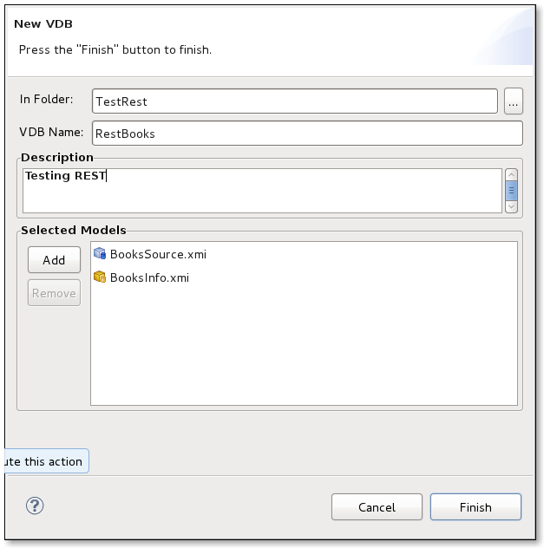
- Click Finish to close the wizard
- Click OK to create the VDB

Deploying the VDB
- Double-click the Deploy VDB action
- Provide a JNDI name for use with the datasource that will be created as part of the deployment process (BooksRestTest)
- Click OK to deploy the VDB and datasource
- Refresh the Teiid view to see the newly deployed datasource and VDB

Generating the REST WAR File
- Double-click the Generate REST war file action
- Verify the correct VDB name is used
- Click OK to launch the wizard
- Verify the information is correct

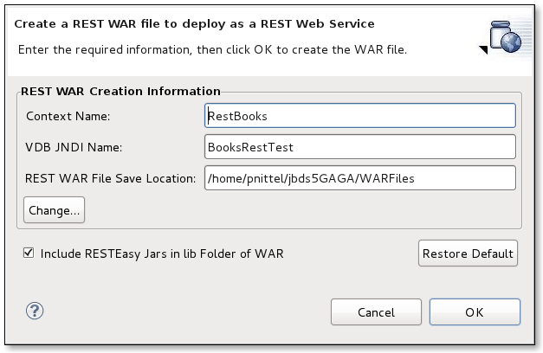
- Click OK to generate the WAR file

Deploying the WAR File
- Double-click the Deploy WAR file action
- After reading the dialog, you will realize the Designer needs a little help to actually deploy the WAR. For the sake of simplicity, copy the WAR file to your server's {profile}/deploy directory.

Querying Through the RESTEasy WAR
Querying through the deployed RESTEasy WAR is done through a Web browser. The format of the URL is:
http://{host}:{port}/{war_context}/{model_name}/{procedure}/{parameter}
where {war_context} is the name of the deployed RESTEasy WAR file,
{model_name} is the name of the model containing the procedure to be executed,
{procedure} is the name assigned in the URI, not the name of the actual procedure,
{parameter} refers to the actual parameter (value) to be passed to the procedure.
A complete example URL is:
http://MyServer:8080/BooksTest/BooksInfo/books/0-201-70225-8
where BooksTest is the name of the WAR, BooksInfo is the model name, and books/0-201-70225-8 is the URI as defined in the procedure's extension properties .
When this URL is entered in your browser, the result should be:

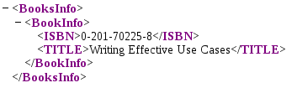

Other valid ISBNs include: 0-7897-2271-2 and 0201877562

