Trek to the Amazon

Objective
Use the ItemLookup Amazon E-Commerce web service operations (SOAP doc literal) to implement a simplified version of the service using our very own books data.

Useful links:

Docs: http://docs.amazonwebservices.com/

Notes
- Part of this test involves paring down the number of operations and the number of mapping classes and attributes. There is more than one way to pare these down and you may use whatever method you choose.

Test Plan

Get started:
- Start the Designer.
- Create a Model Project (name it whatever you wish)

Import the WSDL:
- Import the WSDL from the Amazon Developers’ Web site
  - Import WSDL File into Web Service Model
  - Name the Web service model AWSECommerceService
  - Obtain the WSDL from this URL:
http://webservices.amazon.com/AWSECommerceService/AWSECommerceService.wsdl
  - Edit the WSDL to remove all operations for the portType and binding sections other than ItemLookup (this is the one operation we’ll implement).
  - On the final page of the wizard, uncheck the box to generate the document—doing it manually is much faster.

Set up your relational data:
- Import books from any data source and name the model BOOKS
- Create a virtual relational model—named Logical—with a single view (base table) StagedBooks:

SELECT replace(b.ISBN, '-', '') AS ASIN, (('http://www.amazon.com/exec/obidos/redirect?tag=ws%26link_code=sp1%26camp=2025%26creative=165953%26path=http://www.amazon.com/gp/redirect.html%253fASIN=0321186125%2526tag=ws%2526lcode=sp1%2526cID=2025%2526ccmID=165953%2526location=/o/ASIN/' || replace(b.ISBN, '-', '')) || '%25253FSubscriptionId=0NBNSWQR6RV539N2WV02') AS URL, b.ISBN, NAME AS Publisher, title
FROM BOOKS.BOOKS AS b, BOOKS.PUBLISHERS AS p
WHERE b.PUBLISHER = PUBLISHER_ID

Out of the box, the response document will have bazillions of elements, but we need only a handful. This is why we uncheck the box to generate the document model. Build it manually by following these steps:
- Create a new XML document model named AWSECdoc
- Build from the XSD file created when the WSDL was inported (AWSECommerceService_blah_blah)
- Use only the ItemLookupResponse root element to build the document

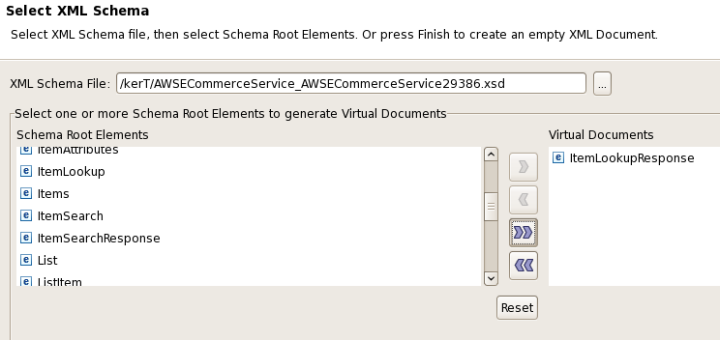

- Click Next (to get to the statistics page)
- Click Next (to get to the Preview Generated Documents page)
- Expand the ItemLookupResponse element
- Following the mapping class diagram below, uncheck the elements not required. Leaving those needed. The illustration below shows part of the process. The selected element must be expanded to reveal the remaining elements you'll need
- Help!
  - Under OperationRequest, uncheck Errors
  - Uncheck Items
  - Under Items, expand Item, then check
    - ASIN
    - DetailPageURL
    - ItemAtributes.Author
    - ItemAttributes.ISBN
    - ItemAttributes.Publisher
    - ItemAttributes.Title

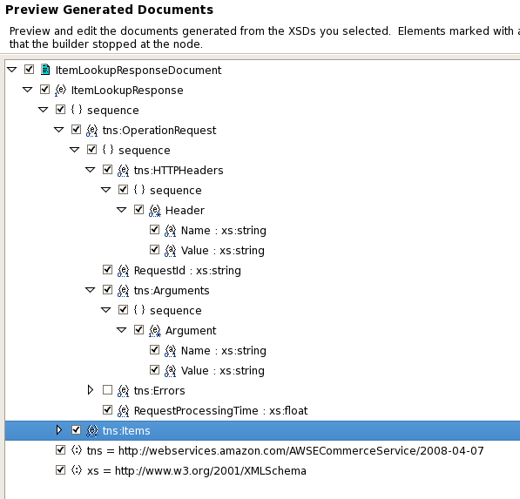

- When you've completed the editing, click Finish
- Open the XML document and its mapping class diagram
- The mapping classes should resemble this:

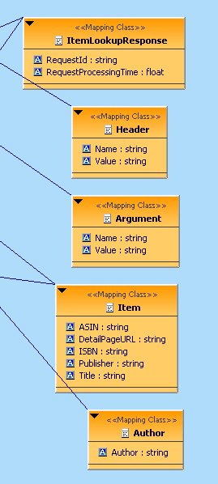

- Map the mapping classes as follows:
  - ItemLookupResponse (hard-code bogus stuff): SELECT '074F6Z69N3T9MRCH9CMY' AS RequestID, convert(0.0185558795928955, float) AS RequestProcessingTime
  - Header: SELECT 'UserAgent' AS Name, 'Mindreef HTTP Client' AS "Value"
  - Argument: SELECT 'Service' AS Name, 'AWSECommerceService' AS "Value"
  - Item: SELECT Logical.StagedBooks.ASIN, URL AS DetailPageURL, Logical.StagedBooks.ISBN, Publisher, TITLE FROM Logical.StagedBooks
  - Author:
    - Create an input set variable using the ISBN from Item
    - SELECT ((a.FIRSTNAME || ' ') || a.LASTNAME) AS Author FROM BOOKS.AUTHORS AS a, BOOKS.BOOK_AUTHORS AS ba WHERE (a.AUTHOR_ID = ba.AUTHOR_ID) AND (ba.ISBN = input.isbn)

Correct the web service operation transformation:
- Transformation will have many more variables than are required for this test. You really need just one ITEMID variable : IN_Request_IN_Itemid
- Here’s a SELECT statement. Depending on how you’ve named things—like the XML document—you’ll need to modify this.

SELECT * FROM AWSECdoc.ItemLookupResponseDocument WHERE context(AWSECdoc.ItemLookupResponseDocument.ItemLookupResponse.Items.Item, AWSECdoc.ItemLookupResponseDocument.ItemLookupResponse.Items.Item.ASIN) = VARIABLES.IN_Request_IN_Itemid;

That should be it – you can now test in VDB Execution with something like this request (note the requested ASIN is in bold red characters—everything else was generated by the SQLExplorer):

EXEC AWSECommerceService.AWSECommerceServicePortType.ItemLookup('<?xml version="1.0" encoding="UTF-8"?>
<ItemLookup xmlns="http://webservices.amazon.com/AWSECommerceService/2007-06-13">
<MarketplaceDomain></MarketplaceDomain>
<AWSAccessKeyId></AWSAccessKeyId>
<SubscriptionId></SubscriptionId>
<AssociateTag></AssociateTag>
<Validate></Validate>
<XMLEscaping></XMLEscaping>
<Shared>
<Condition></Condition>
<DeliveryMethod></DeliveryMethod>
<FutureLaunchDate></FutureLaunchDate>
<IdType></IdType>
<ISPUPostalCode></ISPUPostalCode>
<MerchantId></MerchantId>
<OfferPage></OfferPage>
<ItemId></ItemId>
<ResponseGroup></ResponseGroup>
<ReviewPage></ReviewPage>
<ReviewSort></ReviewSort>
<SearchIndex></SearchIndex>
<SearchInsideKeywords></SearchInsideKeywords>
<VariationPage></VariationPage>
</Shared>
<Request>
<Condition></Condition>
<DeliveryMethod></DeliveryMethod>
<FutureLaunchDate></FutureLaunchDate>
<IdType></IdType>
<ISPUPostalCode></ISPUPostalCode>
<MerchantId></MerchantId>
<OfferPage></OfferPage>
<ItemId>0735608776</ItemId>
<ResponseGroup></ResponseGroup>
<ReviewPage></ReviewPage>
<ReviewSort></ReviewSort>
<SearchIndex></SearchIndex>
<SearchInsideKeywords></SearchInsideKeywords>
<VariationPage></VariationPage>
</Request>
</ItemLookup>

')

The results of this query should resemble the following:

<?xml version="1.0" encoding="UTF-8"?>
<tns:ItemLookupResponse xmlns:xs="http://www.w3.org/2001/XMLSchema"
xmlns:tns="http://webservices.amazon.com/AWSECommerceService/2007-06-13">
<tns:OperationRequest>
<tns:HTTPHeaders>
<tns:Header Name="UserAgent" Value="Mindreef HTTP Client"/>
</tns:HTTPHeaders>
<tns:RequestId>074F6Z69N3T9MRCH9CMY</tns:RequestId>
<tns:Arguments>
<tns:Argument Name="Service" Value="AWSECommerceService"/>
</tns:Arguments>
<tns:RequestProcessingTime>0.01855588</tns:RequestProcessingTime>
</tns:OperationRequest>
<tns:Items>
<tns:Item>
<tns:ASIN>0735608776</tns:ASIN>
<tns:DetailPageURL>http://www.amazon.com/exec/obidos/redirect?tag=ws%26link_code=sp1%26camp=2025%26creative=165953%26path=http://www.amazon.com/gp/redirect.html%253fASIN=0321186125%2526tag=ws%2526lcode=sp1%2526cID=2025%2526ccmID=165953%2526location=/o/ASIN/0735608776%25253FSubscriptionId=0NBNSWQR6RV539N2WV02</tns:DetailPageURL>
<tns:ItemAttributes>
<tns:ISBN>0-7356-0877-6</tns:ISBN>
<tns:Publisher>Microsoft Press</tns:Publisher>
<tns:Title>After the Gold Rush</tns:Title>
<tns:Author>Steve McConnell</tns:Author>
</tns:ItemAttributes>
</tns:Item>
</tns:Items>
</tns:ItemLookupResponse>

Playing with Amazon’s Actual Web Service

(Alex’s notes from 2006. With the passage of time, YMMV!)

Create your own web service ID (AWSAccessKeyID): http://www.amazon.com/gp/browse.html/102-3350751-9356939?node=3435361

Example request (red) and response (blue) from hitting the actual Amazon Web Service (done from SoapScope) are below. This request looks up a book (which just happens to be a multi-author book in our books database). Amazon takes an ASIN ID which for books appears to just be the ISBN with –‘s removed. Data values in the XML haze below are bolded.

<soapenv:Envelope
xmlns:soapenv="http://schemas.xmlsoap.org/soap/envelope/">
<soapenv:Body>
<tns:ItemLookup
xmlns:soapenc="http://schemas.xmlsoap.org/soap/encoding/"
xmlns:xsi="http://www.w3.org/2001/XMLSchema-instance"
xmlns:tns="http://webservices.amazon.com/AWSECommerceService/2006-03-08"
xmlns:xsd="http://www.w3.org/2001/XMLSchema">
<tns:AWSAccessKeyId>Your key here</tns:AWSAccessKeyId>
<tns:Shared>
<tns:ItemId>0130147141</tns:ItemId>
</tns:Shared>
</tns:ItemLookup>
</soapenv:Body>
</soapenv:Envelope>

<SOAP-ENV:Envelope
xmlns:SOAP-ENV="http://schemas.xmlsoap.org/soap/envelope/"
xmlns:SOAP-ENC="http://schemas.xmlsoap.org/soap/encoding/"
xmlns:xsi="http://www.w3.org/2001/XMLSchema-instance"
xmlns:xsd="http://www.w3.org/2001/XMLSchema">
<SOAP-ENV:Body>
<ItemLookupResponse xmlns="http://webservices.amazon.com/AWSECommerceService/2006-03-08">
<OperationRequest>
<HTTPHeaders>
<Header Name="UserAgent" Value="Mindreef HTTP Client" />
</HTTPHeaders>
<RequestId>0M89G00Z2NEFN3H1FKQX</RequestId>
<Arguments>
<Argument Name="Service" Value="AWSECommerceService" />
</Arguments>
<RequestProcessingTime>0.020488977432251</RequestProcessingTime>
</OperationRequest>
<Items>
<Request>
<IsValid>True</IsValid>
</Request>
<Item>
<ASIN>0130147141</ASIN>
<DetailPageURL>http://www.amazon.com/exec/obidos/redirect?tag=ws%26link_code=sp1%26camp=2025%26creative=165953%26path=http://www.amazon.com/gp/redirect.html%253fASIN=0130147141%2526tag=ws%2526lcode=sp1%2526cID=2025%2526ccmID=165953%2526location=/o/ASIN/0130147141%25253FSubscriptionId=0NBNSWQR6RV539N2WV02</DetailPageURL>
<ItemAttributes>
<Author>Charles F. Goldfarb</Author>
<Author>Paul Prescod</Author>
<Manufacturer>Pearson Education</Manufacturer>
<ProductGroup>Book</ProductGroup>
<Title>The XML Handbook (2nd Edition)</Title>
</ItemAttributes>
</Item>
</Items>
</ItemLookupResponse>
</SOAP-ENV:Body>
</SOAP-ENV:Envelope>

If you paste the value of the DetailPageURL portion of the response in a browser address, you will go to Amazon’s page for the book. Cool!

