E2E Dynamic SQL Test Script

This test script exercises Enterprise Designer in the process of testing the use of Dynamic SQL in transformations.

Overview
Multiple customers have requested the ability to have a more dynamic level of control over their queries in a virtual procedure based on procedure inputs. Currently, the best answer to this is usually to create a series of nested if/else statements based on procedure inputs to choose a query with specific criteria appropriate to the inputs. In the case of even a small number of parameters this can quickly become a maintenance headache. This feature covers the implementation of dynamic SQL to alleviate this problem.

Setup
Install the Designer. Everything else is crafted by hand.

Test
- Start the Designer
- Close the Welcome page
- Create new a project—Name it as you choose
- Import Customer Accounts from SQL Server

Connection Property | Value
JDBC URL | jdbc:mmx:sqlserver://slntdb02:1433;DatabaseName=customeraccounts
Username | customeraccounts
Password | mm

- Name the imported model Customer_Accounts
- Create a Relational View model
  - Name the model Customer
  - Use the optional builder to transform from an existing model
  - Transform from Customer_Accounts
  - Delete the Account and AccountHoldings tables from the model
- Rename the Customer.Customer table to Customer.Accounts
- Create another Relational View model
- Name the model AccountAccess
- Add a procedure named getAccount
- To the procedure add these input parameters:
  - ID (string, length = 12, NULLABLE, no default value)
  - lName (string, length = 25, NULLABLE, no default value)
  - phoneLast4 (string, length = 4, NULLABLE, no default value)
- To the procedure results, add these columns:
  - rs_ID (string, length = 12)
  - rs_Name (string, length = 51)
  - rs_Phone (string, length = 30)
- The VDB Explorer tree should resemble this:

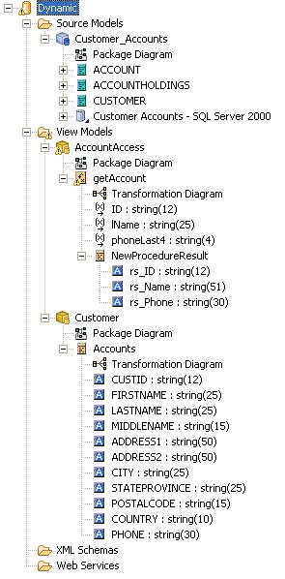

- Open the transformation diagram for getAccount
- Add the following SQL to define the transformation:

CREATE VIRTUAL PROCEDURE
BEGIN
DECLARE string VARIABLES.crit = null;
IF(AccountAccess.getAccount.ID IS NOT NULL)
BEGIN
VARIABLES.CRIT = '(Customer.Accounts.CUSTID = using.ID)';
END
ELSE
BEGIN
IF(AccountAccess.getAccount.lName IS NOT NULL)
BEGIN
IF(AccountAccess.getAccount.lName = '%')
BEGIN
ERROR 'Last name cannot be a complete wildcard';
END
ELSE
BEGIN
IF(LOCATE('%', AccountAccess.getAccount.lName) < 0)
BEGIN
VARIABLES.CRIT = '(Customer.Accounts.LastName = using.lName)';
END
ELSE
BEGIN
VARIABLES.CRIT = '(Customer.Accounts.LastName LIKE using.lName)';
END
END
IF(AccountAccess.getAccount.phoneLast4 IS NOT NULL)
BEGIN
VARIABLES.CRIT = (('(' || VARIABLES.CRIT) || ' and (RIGHT(Customer.Accounts.PHONE, 4) = using.phoneLast4))');
END
ELSE
BEGIN
ERROR 'If not using ID, you must use LastName AND last 4 digits of phone number';
END
END
ELSE
BEGIN
ERROR 'Either ID or LastName and last 4 digits of the phone number must be specified.';
END
END
EXECUTE STRING ('SELECT CUSTID as rs_ID, FirstName || '' '' || LastName AS rs_Name, PHONE as rs_Phone
FROM Customer.Accounts WHERE ' || VARIABLES.CRIT) USING ID = AccountAccess.getAccount.ID, lName = AccountAccess.getAccount.lName, phoneLast4 = AccountAccess.getAccount.phoneLast4;
END

- Validate the SQL
- The transformation diagram should resemble this:

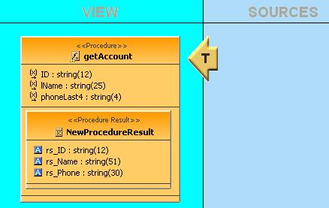

- Save All
- Create a VDB and name it whatever you wish
  - Add the AccountAccess model
  - No other models are added as this dynamic SQL has no concrete dependencies.
  - Manually add the Customer model to the VDB and the Customer_Account model will be automatically added as well.
- Set up the connector binding, if not already established
- Execute the VDB
- Generate a Select for, and query, Customer.Accounts
- Write down the CUSTID, LASTNAME, and last four digits of PHONE for a couple customers
- Generate the Exec for the AccountAccess.getAccount procedure—it will resemble this:
EXEC AccountAccess.getAccount( ID_string , lName_string , phoneLast4_string )
- Modify the query to access one account by ID—for example:
EXEC AccountAccess.getAccount( ID='CST01022' )
- Execute the query (click the Running Dude)
- Verify the SQL Results show three columns (rs_ID, rs_Name, rs_Phone) with the corresponding values from the selected customer—for example:

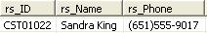

- Again, generate the Exec
- Modify the query to access one account by last name and phone number—for example:
EXEC AccountAccess.getAccount( lName='Aire' , phoneLast4='6789' )
- Verify the SQL Results show three columns with the corresponding values from the selected customer—for example:

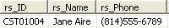

- Execute other queries, such as:
EXEC AccountAccess.getAccount( )
EXEC AccountAccess.getAccount( 'CST01004', 'Aire', '6789' )
EXEC AccountAccess.getAccount( phoneLast4='6789' )
EXEC AccountAccess.getAccount( lName='Aire' )
EXEC AccountAccess.getAccount( lName='%' , phoneLast4='6789' )
EXEC AccountAccess.getAccount( lName='Air%' , phoneLast4='6789' )
- Switch back to the Designer perspective
- Right-click > clone getAccount
- Name the new procedure getAccount2
- Open the transformation editor
- Paste the following SQL into the transformation editor:

CREATE VIRTUAL PROCEDURE
BEGIN
DECLARE string VARIABLES.crit = null;
IF(AccountAccess.getAccount2.ID IS NOT NULL)
BEGIN
VARIABLES.CRIT = (('(Customer.Accounts.CUSTID = ''' || AccountAccess.getAccount2.ID) || ''')');
END
ELSE
BEGIN
IF(AccountAccess.getAccount2.lName IS NOT NULL)
BEGIN
IF(AccountAccess.getAccount2.lName = '%')
BEGIN
ERROR 'Last name cannot be a complete wildcard';
END
ELSE
BEGIN
IF(LOCATE('%', AccountAccess.getAccount2.lName) < 1)
BEGIN
VARIABLES.CRIT = (('(Customer.Accounts.LASTNAME = ''' || AccountAccess.getAccount2.lName) || ''')');
END
ELSE
BEGIN
VARIABLES.CRIT = (('(Customer.Accounts.LASTNAME LIKE ''' || AccountAccess.getAccount2.lName) || ''')');
END
END
IF(AccountAccess.getAccount2.phoneLast4 IS NOT NULL)
BEGIN
VARIABLES.CRIT = (((('((' || VARIABLES.CRIT) || ') and (RIGHT(Customer.Accounts.PHONE, 4) = ''') || AccountAccess.getAccount2.phoneLast4) || '''))');
END
ELSE
BEGIN
ERROR 'If not using ID you must enter both the last name AND the last 4 digits of the phone number';
END
END
ELSE
BEGIN
ERROR 'ID or LastName and last 4 digits of the phone number must be specified.';
END
END
EXECUTE STRING ('SELECT CUSTID as rs_ID, FIRSTNAME || '' '' || LASTNAME AS rs_Name, PHONE as rs_Phone
FROM Customer.Accounts WHERE ' || VARIABLES.CRIT);
END

- Validate the SQL
- Save All
- Synchronize the VDB
- Execute the VDB
- Execute the same queries you executed for getAccount—the results should be the same.

